Multiple Cities Load Shedding Using ARM

Load Shedding in electrical supply networks is a controlled process in which the utility company drops off part of the load in order to balance the demand and the generated capacity. Utility company use scheduled load shedding so that the available electricity is fairly shared by the consumer. To understand this procedure in deep we propose “Multiple cities load shedding management using ARM”.
Multiple cities load shedding management system is a reliable circuit that takes over the manual task of switch ON/OFF the electrical devices with respect to time. In ARM controller we have in-built RTC which monitors times and switches off the load accordingly. In our project we connect 3 load which represent 3 different cities. By using a keypad the user will enter the current time as well as the desired time for cutting OFF and switching the load of the particular city. After taking all the inputs from the user the system will start monitoring time from the current time which is been entered by the user in the start. So as and when the time for switching ON/OFF a particular city occurs the system will accordingly switch ON/OFF that particular city. To keep a track of the load shedding that mean if someone wants to know which city is going through load shedding then they can check it on LCD as it will display the city number which is going through load shedding thus keeping a track or monitoring is made easy. An additional advantage of this project is that the user can schedule the time as per his requirement there is no fixed scheduling and as it is dependent on user the consumers can be well informed about the load shedding so that he can postponed or pre-pone his important work accordingly thus there is no loss for the company as well as to the consumer.

Block Diagram :

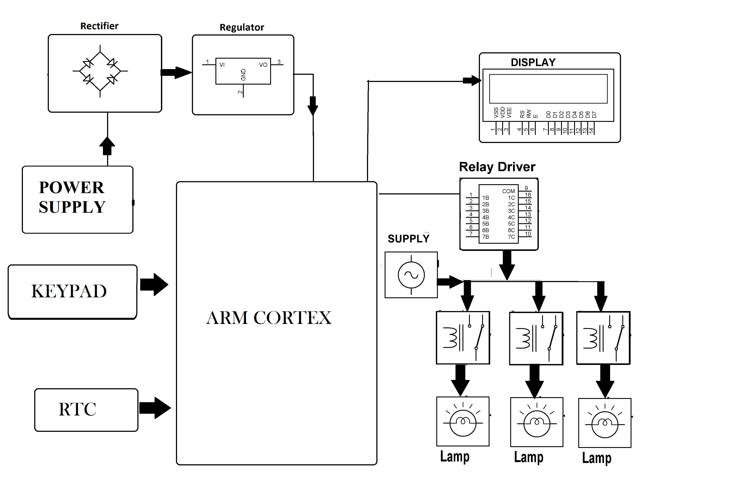

Hardware Specifications :
- Power Supply
- Rectifier
- Regulator
- LCD
- Keypad
- RTC
- ARM Cortex
- Lamp
- Relay Driver
- Resistors
- Capacitors
- Diodes

Software Specifications
- Arduino ide
- MC Programming Language: C

